**DFD RPL**

**RESTORAN PAK**

**Kelompok Eggnog :**

1. **Luthfi Salman Arif Suhanda – 10117009**
2. **Seno Ramadhani**
3. **Dias Rafly Mahendra**
4. **M Fauzi**
5. **M Farhan Difa**

|  |
| --- |
| CONTEXT DIAGRAM |
| **C:\Users\X\Downloads\DFD Restoran-Context Diagram (2).jpg** |

|  |  |
| --- | --- |
| C:\Users\X\Downloads\DFD Restoran-Level 1 (4).jpg | DFD LEVEL 1 |

# DFD LEVEL 2

## Level 2 – 1.1

## Level 2 – 2.1C:\Users\X\Downloads\DFD Restoran-Level 2 - 2.1.jpg

## Level 2 – 3.1

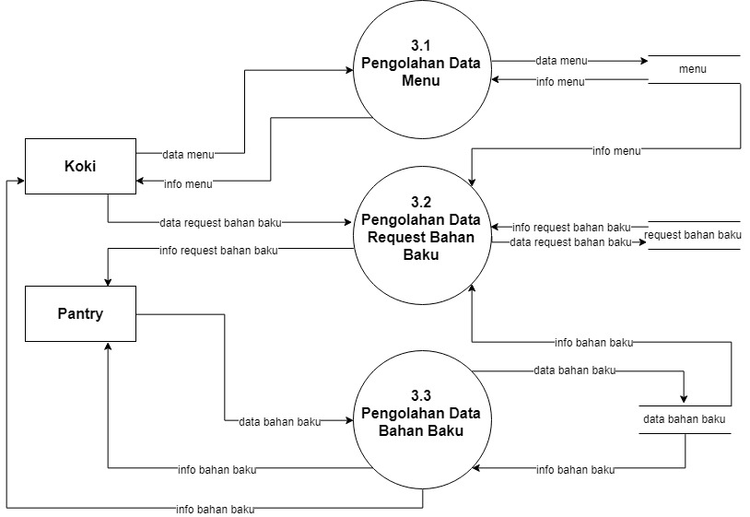

## Level 2 – 4.1

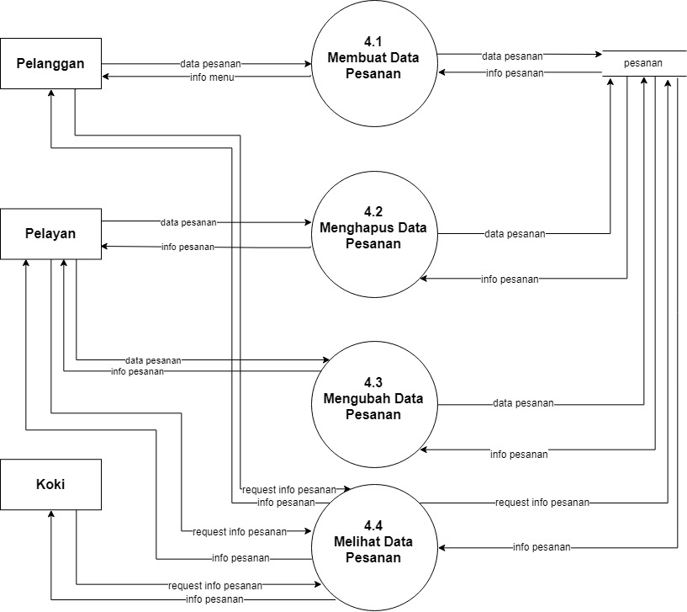

## Level 2 – 5.1

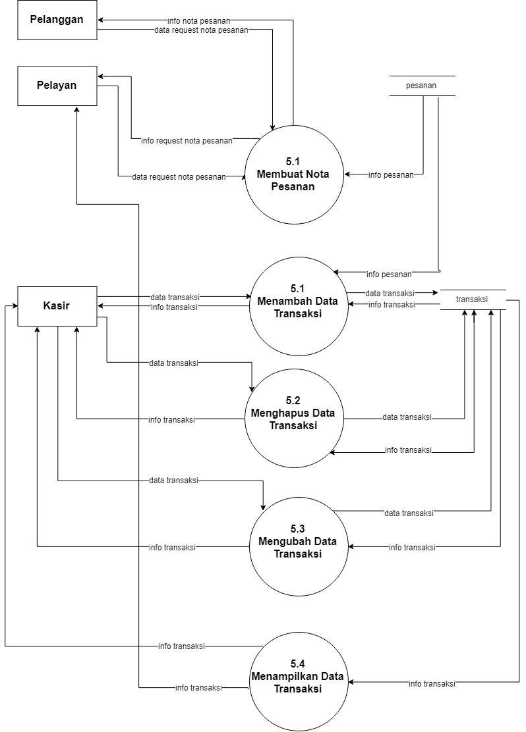

## Level 2 – 6.1C:\Users\X\Downloads\DFD Restoran (3) (2) (1) (1) (1)-Level 2.jpg

## Level 2 – 7.1

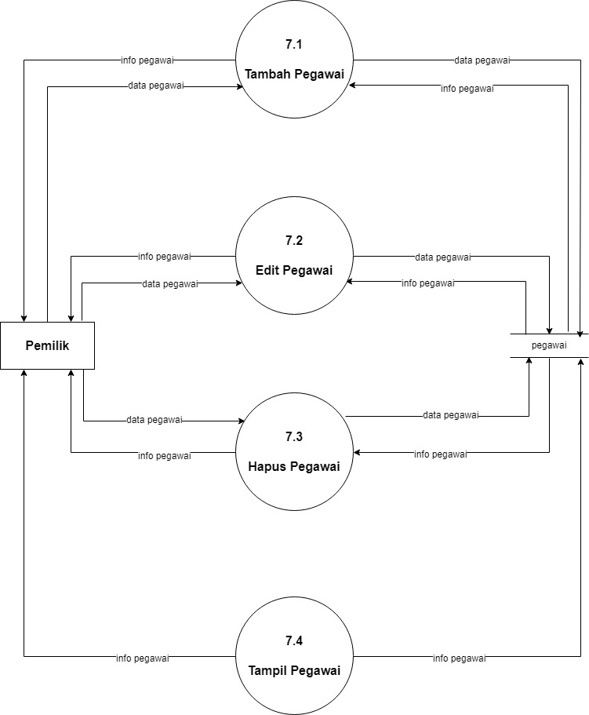

## Level 2 – 8.1

## C:\Users\X\Downloads\DFD Restoran (3) (2) (1) (1) (1)-Level 2 (3).jpg